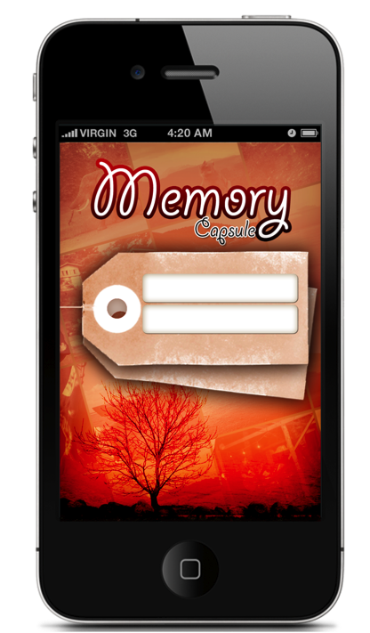

The example of the opening page when the app is opened:

**login / sign in page.**

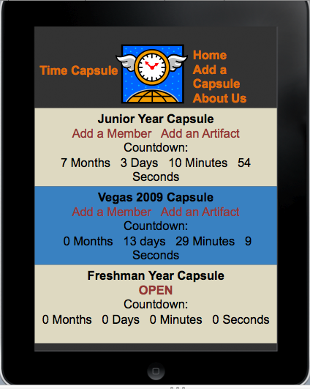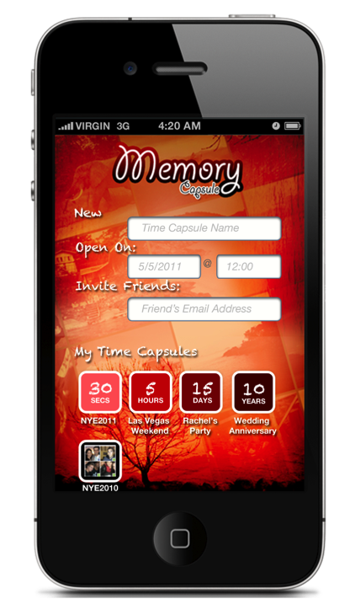

This is another example of what the home page could look like, or, even better I think, the page that opens when a new capsule is created.

If you click invite friends, it can take you to a buddy list.

-I think this would be a really cool way to open the app, showing all existing time capsules, and their running clocks. And we can have both the opened and closed capsules. The consumer would then be able to click and open each capsule.

- We could also have a button that lets the user create a new capsule.

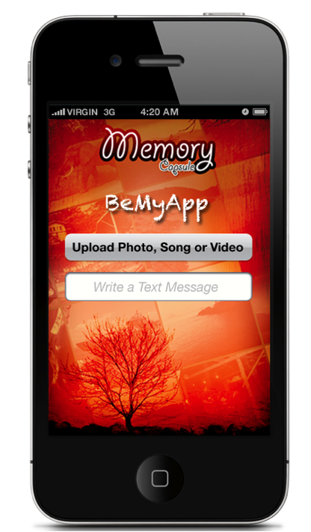

It would be cool too, if the countdown until the opening was continuously going on this page.

Here is a very bare example of an unopened capsule, where we can upload photos, and preferably it would open up to a camera within the app.





Opened capsule!

If we click on a photo, it will take us to it, hopefully showing when it was taken, who took it, and an option to share on fb, twitter, email ect.